BMW WORLDWIDE SALES ANALYSIS
(2010-2024)


OVERVIEW
The automotive industry is highly competitive, with manufacturers constantly seeking to understand market trends, customer preferences, and sales performance. This project focuses on BMW worldwide sales data from 2010 to 2024 to analyze trends, identify top-performing models, and evaluate regional sales patterns. The analysis uses SQL and Excel to derive actionable insights that can help BMW improve strategic decision-making.

(Power Query + SQL Integrated Project)

Business Problem
BMW operates in a highly competitive global automotive market where customer preferences, regional demand, and product performance change rapidly. However, BMW lacks a clear, data-driven understanding of:
- Which regions are performing strongly or weakly
- Which models are preferred by customers
- How pricing, transmission, and fuel type influence sales
- Which factors drive high sales volume and low sales performance
Without these insights, BMW cannot fully optimize its market strategy, inventory planning, pricing decisions, or marketing efforts. To stay competitive and increase sales, BMW needs a structured analysis of its global sales trends from 2010–2024.

Solution Goal
The primary objectives of this project are:
- Analyze sales trends over the 2010–2024 period.
- Identify top-performing models by region, prices and its specifications.
- Evaluate market trends, sales performance and customer preference to guide production, inventory and marketing.
- Provide recommendations to optimize BMW’s sales strategy.

DATA DESCRIPTION
Source: Kaggle – BMW Worldwide Sales Records
Time Span: 2010–2024
Attributes/Columns:
Column Name - Description
Model -BMW car model name
Year - Year of sale
Region - Sales region (continent/country)
Color - Color of the car
Fuel type - Petrol, Diesel, Hybrid, Electric
Transmission -Manual / Automatic
Engine size -Engine capacity in liters
Mileage km - Mileage of car in kilometers
Price used - Sale price in USD
Sales volume -Number of units sold
Sales Classification-High/low

DATA CLEANING STEPS
- checked duplicates and null values
- column names
- numerical value
- Normalized categorical data and outliers
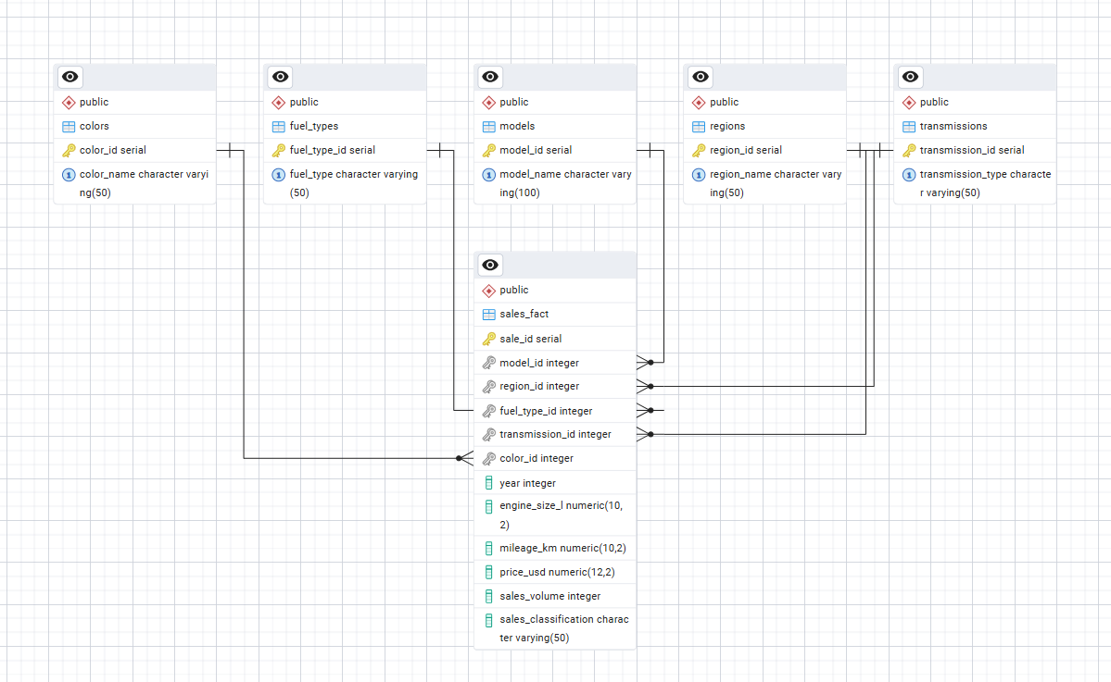
The data model follows a 1-to-many relationship pattern, where each dimension table is linked to many records in the fact table.
- Fact Table: sales_fact
- Multiple Dimension Tables:
Colors, fuel_types, models, regions, transmissions
The fact table stores measurable data (numbers you want to analyze), while the Dimension tables store descriptive details

Market trend Analysis
1.How has electric car sales changed over years compared to petrol and diesel
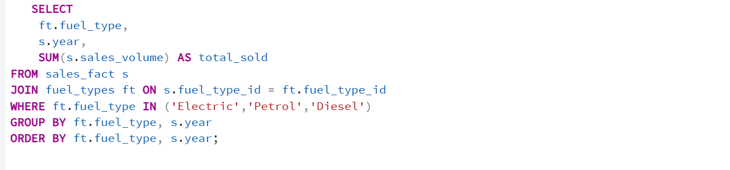
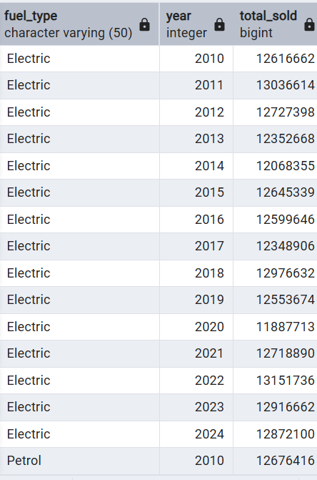
Insights
- Electric vehicle (EV) sales are increasing steadily year after year.
- Petrol and diesel show declining or stagnant growth in recent years.
- EV demand grows fastest after 2020, indicating a shift in customer preference.
2. Price range for each region
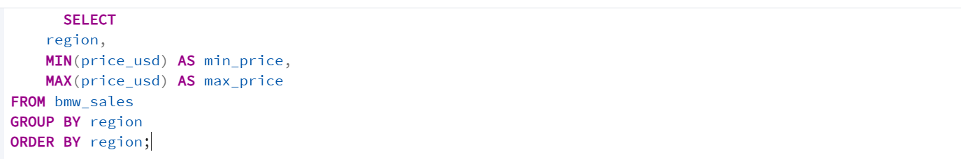
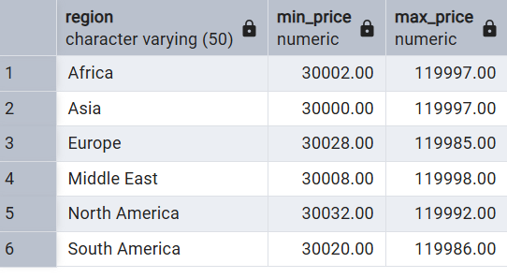
insights
Some regions consistently sell high-priced models (premium segments).
Others show lower price ranges, indicating price-sensitive markets.
A wide gap in minimum and maximum prices shows varied customer purchasing power.

3.What is the average price of BMW cars each year?
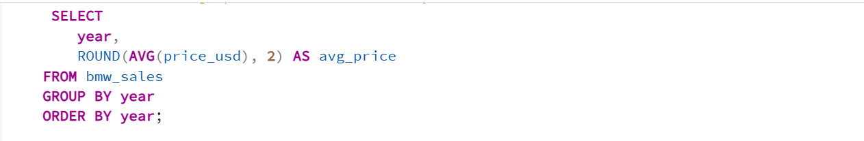
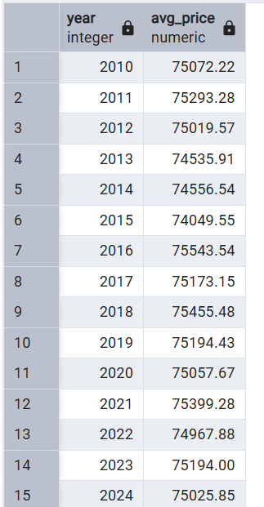
Insights
- Average price shows gradual growth over time.
- Peaks indicate premium model launches or inflation. (2016)
- Dip years may reflect introduction of more budget-friendly models . (2015)

SALES ANALYSIS
4.What was the total sales volume per year?
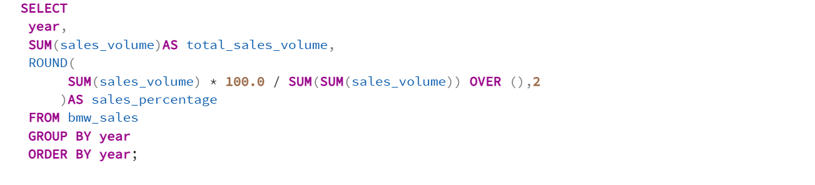
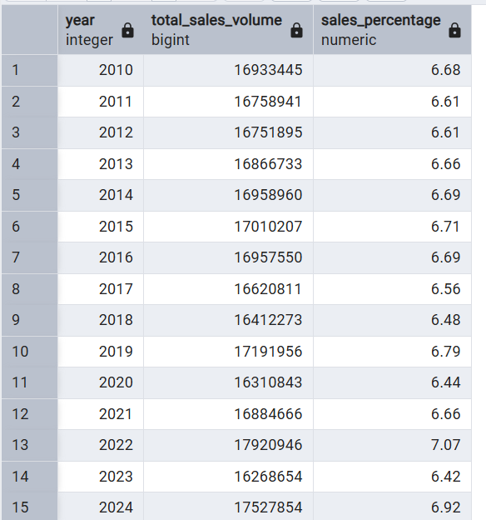
Insights
- Sales peak in certain years showing strong demand cycles. (2022)
- Declines may reflect economic downturns or supply-chain issues. (2020)
- Percentage share reveals which years were most successful for BMW.

- Models generating the most revenue each year
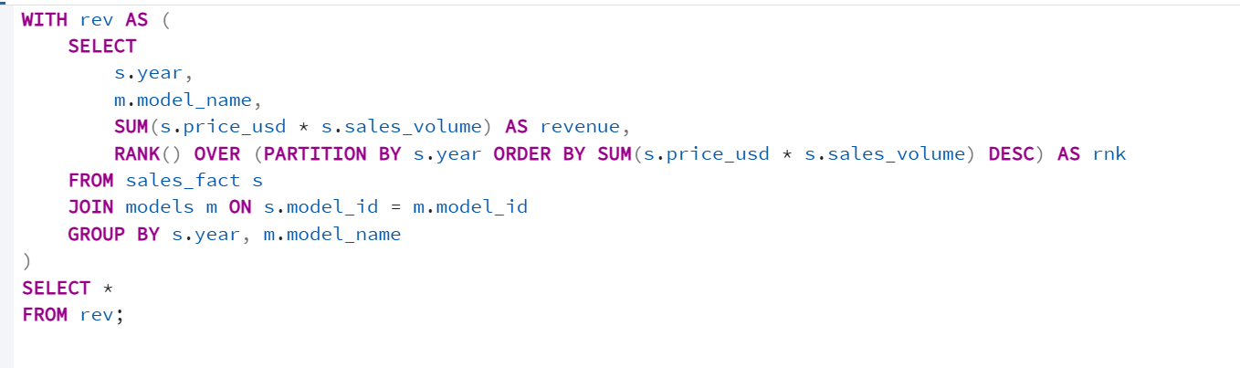
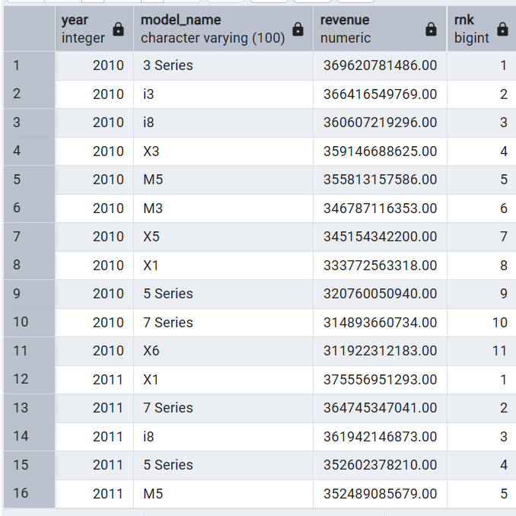
Insights
- A few premium BMW models dominate total yearly revenue.
- Revenue leaders vary slightly by year, showing shifting customer trends.
- Models with high revenue combine strong demand + high price points.

- Top regions by total sales volume
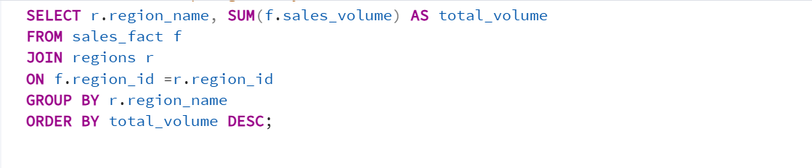
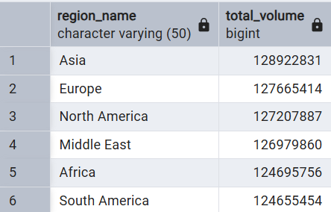

Insights

- Specific regions consistently contribute the highest sales volume.
- Low-volume regions indicate lack of brand reach or market penetration.

- which are the top 5 models by total sales volume?
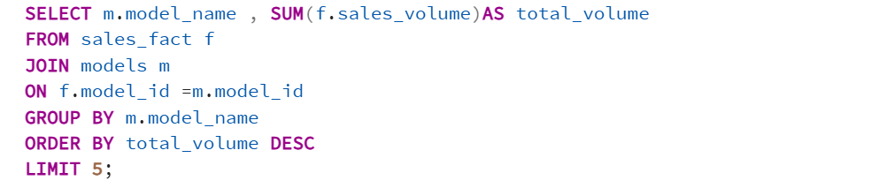
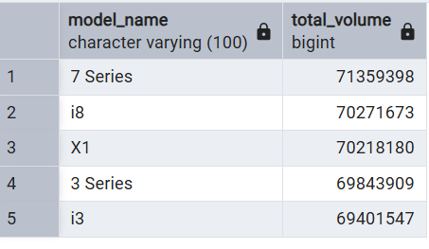
Insights
- A fixed set of models repeatedly appear in the top 5.
- These models represent BMW’s core customer preference.
- High-volume models often align with competitive pricing and broad demand.
CUSTOMER PREFERENCE
8. Which car colors are most preferred by customers?
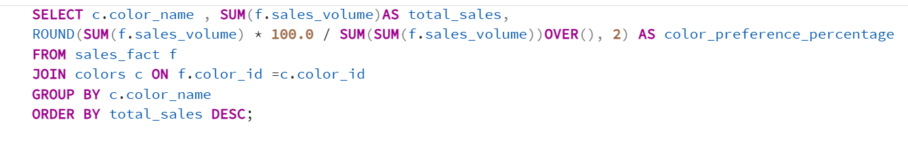
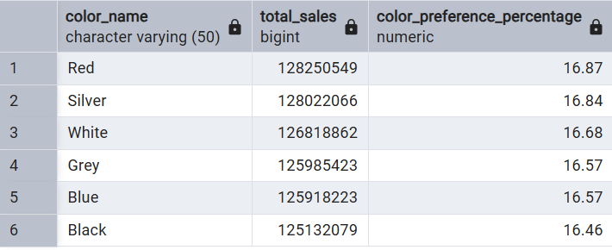
Insights
- Certain colours dominate (like red, silver, white).
- Customer colour preference is stable over years.
- Unique or special edition colours contribute low volumes.

9.most preferred transmission type
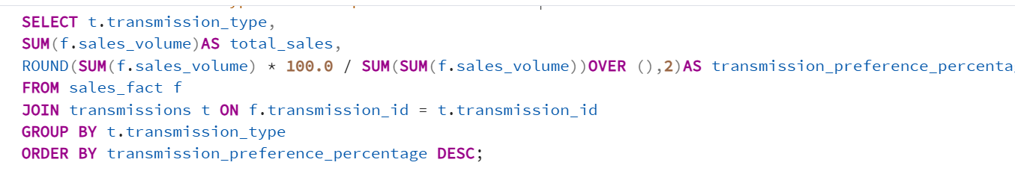
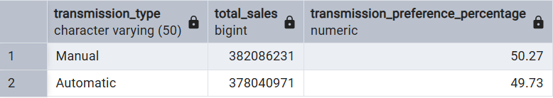
Insights
- Manual transmission is preferred far more than automatic.
- Preference shift aligns with global driving convenience trends.
10. what is the sales volume by fuel type?
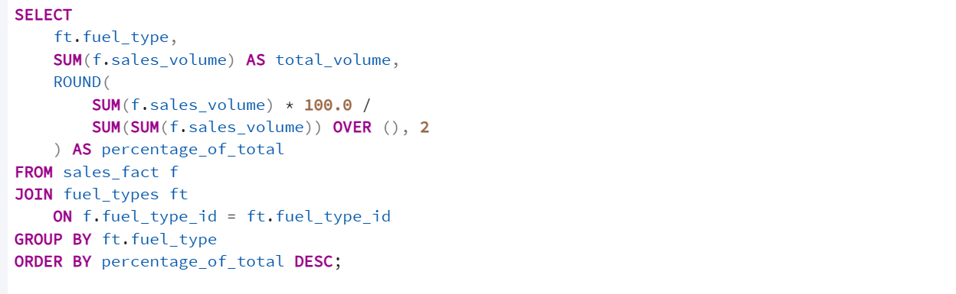
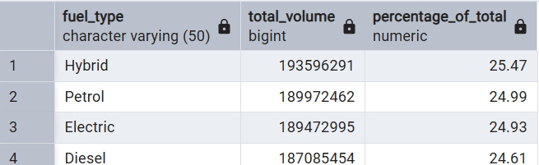
Insights
- hybrid leads total sales volume historically.
- Diesel gradually declines due to regulations and customer shift.
- Electric vehicles grow but still hold a smaller share compared to hybrid.

RECOMMENDATIONS
1. Boost Electric Vehicle Strategy
- Increase EV production in regions where adoption is fastest
- Offer EV-specific incentives to accelerate transition.
2. Adjust Pricing Based on Regional Sensitivity
- Use high-price regions to push premium models.
- Offer more entry-level variants in price-sensitive markets.
3. Promote High Revenue Models
- Focus advertising and inventory on top revenue-generating models.
- Introduce new variants or feature upgrades to maintain interest.
4. Strengthen Presence in Weak Regions
- Use localized marketing strategies.
- Partner with dealers to increase brand awareness.
- Consider region-specific promotions.
5. Align Inventory with Customer Preferences
- Stock more manual transmission vehicles.
- Prioritize popular colours and reduce low-demand colours.
- Keep hybrid models strong while slowly transitioning lineup to EVs.

conclusion
The data clearly shows evolving customer preferences across regions, model types, and fuel choices. BMW’s future growth strongly depends on increasing electric vehicle adoption, optimizing region-wise pricing, and leveraging its top-revenue and top-volume models. By aligning production, marketing, and inventory strategies with these insights, BMW can strengthen market competitiveness and support long-term global expansion.

